
Information Strategy and Services

DUO Login Visual Change 2026
Table of Contents
New Visual Experience 1
Login Experience as of March 2026 1

New Visual Experience
  - Logging into a Secure Resource
DUO is the tool used for Multi-Factor Authentication (MFA) across the university. The application has been updated to a newer version with enhanced security, which has resulted in some changes to the visual experience when using DUO for MFA.

There is no change to how you log into a secure university resource, the process remains the same, but you will see a new loading screen that previously was not part of the user experience.

Login Experience as of March 2026
  - New Visual Experience
Still have questions? Contact the Service Desk: call 303.724.4357 (4-HELP from a campus phone) or open a ticket at servicecenter.oit.ucdenver.edu/CherwellPortal.
Updated on: DATE

Cre

Access the desired secure resource as usual.

Step 1: Login with your university credentials when prompted
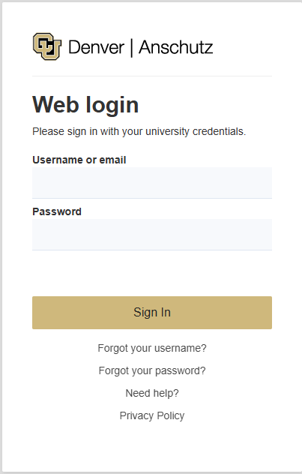
Step 2: After entering your credentials, you will see this new loading screen briefly while you are redirected to a DUO-hosted webpage (duosecurity.com) for Multi-Factor Authentication (MFA).

New loading screen
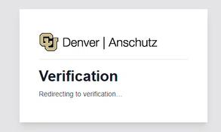

Step 3: The DUO authentication screen loads, select “Send Me a Push” and verify on your connected device.

Note: Push verification is the most secure method of MFA verification as calls and passcodes are more susceptible to phishing.
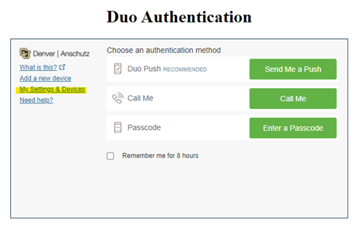

Step 4: Verify that the Push request on your device matches your location and request time; if it is you requesting, approve the Push and login to the secure university resource.

If you receive a Push verification request that does NOT match your location or attempt to access a secure resource, decline the Push and report the incident to the Service Desk.

